AI ASSISTANT CODING ASSIGNMENT 2

NAME : MD SHAHID
ROLL NO : 2303A51421
BATCH NO : 21

Task 1: Cleaning Sensor Data ❖ Scenario:
- You are cleaning IoT sensor data where negative values are invalid.
- Task:
Use Gemini in Colab to generate a function that filters out all negative numbers from a list.
- Expected Output:
- Before/after list
- Screenshot of Colab execution

OUTPUT:

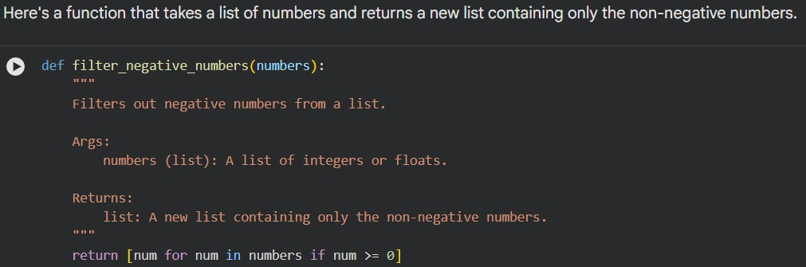

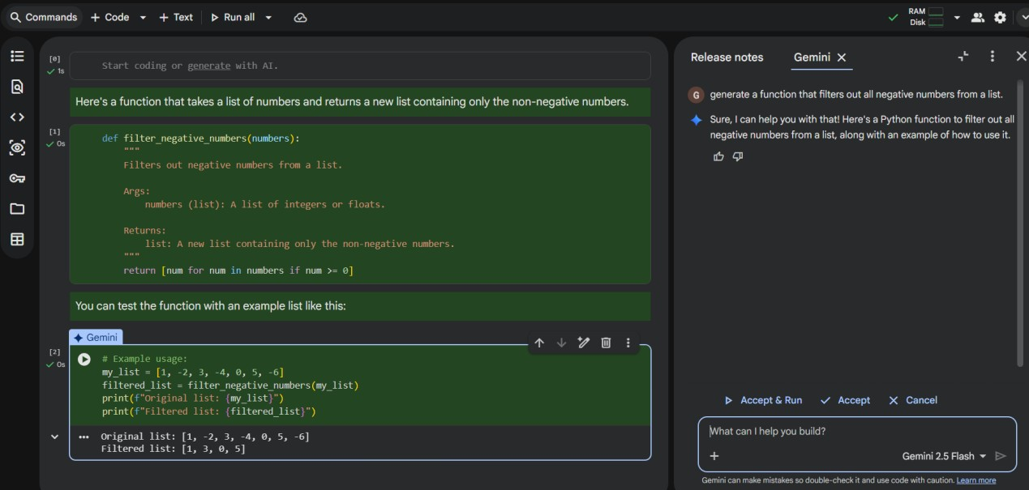

Task 2: String Character Analysis
- Scenario:
You are building a text-analysis feature.
- Task:
Use Gemini to generate a Python function that counts vowels, consonants, and digits in a string.
- Expected Output: ➢ Working function
➢ Sample inputs and outputs

OUTPUT:

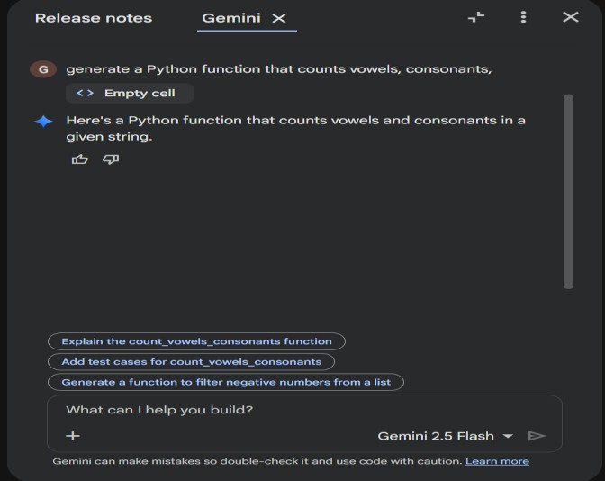

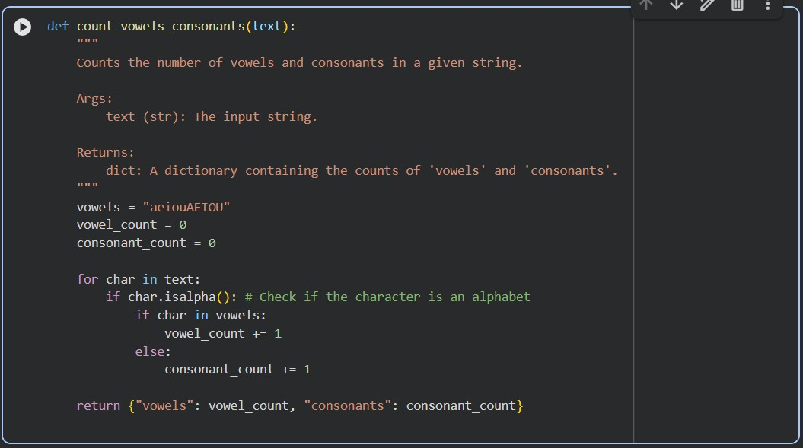

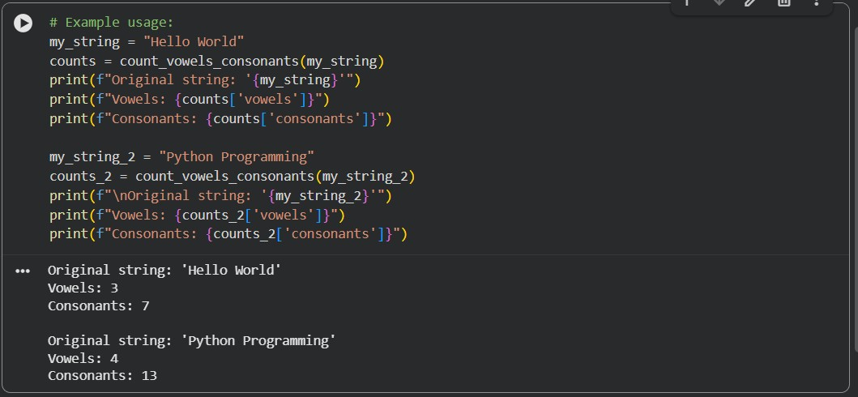

Task 3: Palindrome Check – Tool Comparison
- Scenario:
You must decide which AI tool is clearer for string logic.
- Task:
Generate a palindrome-checking function using Gemini and Copilot, then compare the results.
- Expected Output:
- Side-by-side code comparison
- Observations on clarity and structure

Output :

CODE GENERATED BY GEMINI:

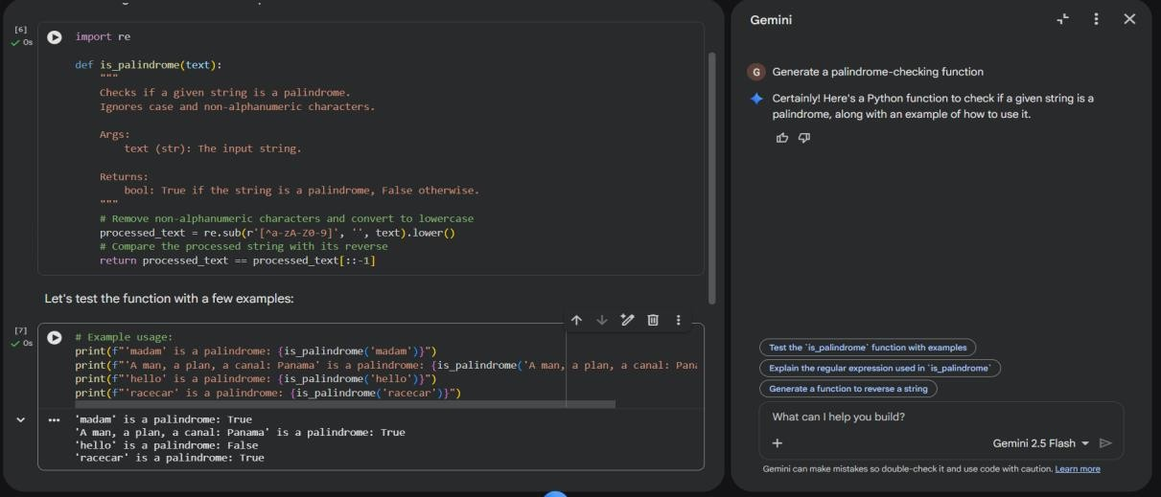

CODE GENERATED BY COPILOT :

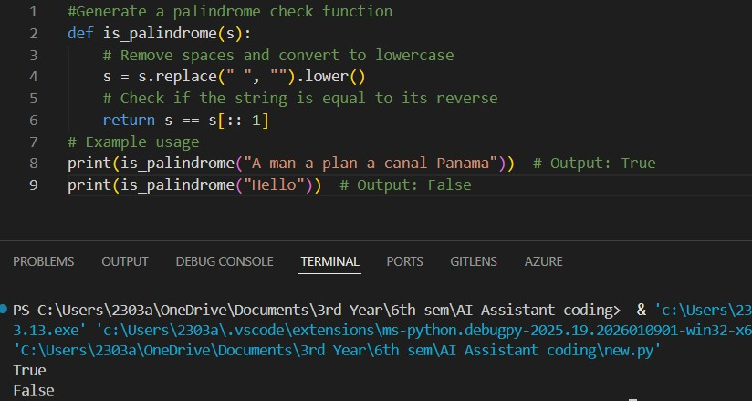

Observations on Clarity

Improved Version:

Gemini Code:
- Clear, well-documented, and includes a proper docstring explaining the function’s purpose, parameters, and return value.
- Professionally structured with a reusable function and multiple test cases.
- Handles edge cases thoroughly by stripping non-alphanumeric characters and normalizing case.
Copilot Code:
- Simple and easy to understand, especially for beginners.
- Uses a short variable name (s)—functional but not descriptive.
- Produces only a raw True/False output with no additional context.
- Structurally compact, focusing only on space removal and lowercase conversion.
Summary:
- Gemini’s version is more complete, robust, and ready for real-world use.
- Copilot’s version is minimal and beginner-friendly—fine for quick checks but not as comprehensive.

Task 4: Code Explanation Using AI
- Scenario:
You are reviewing unfamiliar code written by another developer.
- Task:
Ask Gemini to explain a Python function (prime check OR palindrome check) line by line.
- Expected Output:
- Code snippet
- AI explanation
- Student comments on understanding

OUTPUT :

AI Explanation :

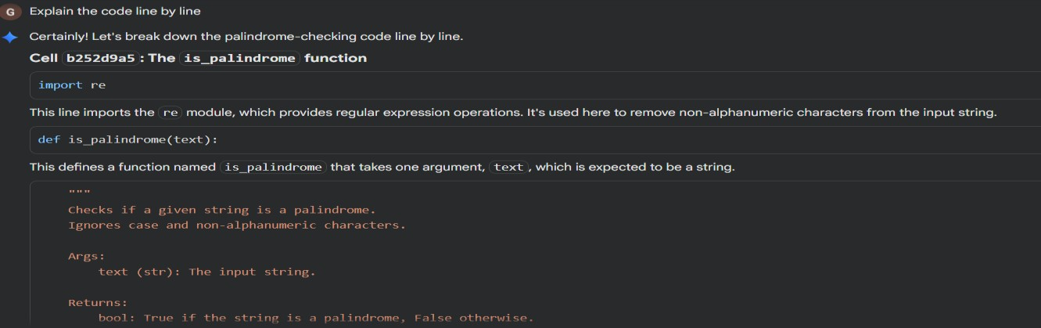

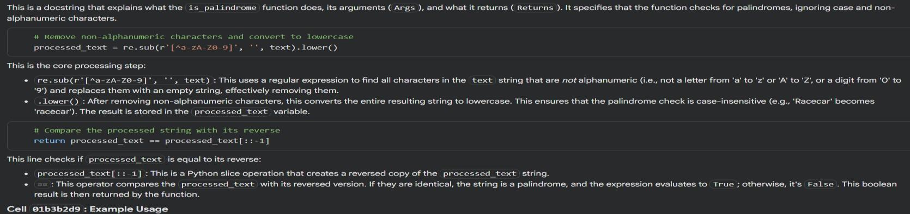

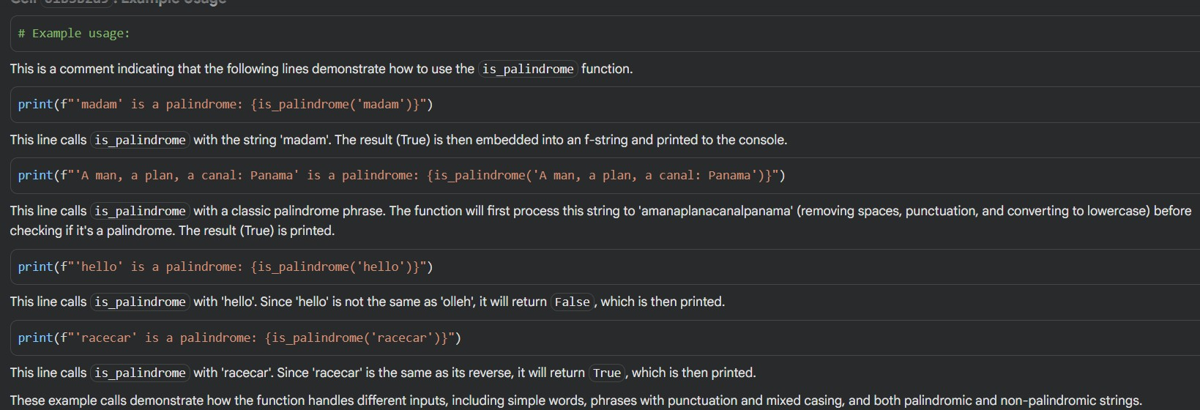

Clear Understanding:
- “The explanation made the role of regular expressions clear—I finally understand how they clean the string.”
- “I see why .lower() matters now; it ensures the palindrome check is case-insensitive.”
- “The slicing trick [::-1] was new to me, and it’s an elegant way to reverse a string.”
- “The examples clarified everything, especially how the function handles both simple words and more complex phrases.”

